1. 1) Client, visit if pass by

2) Pass by supermarket; do not forget to buy…

3) It is approaching my home

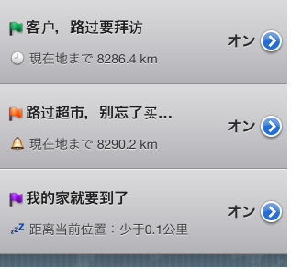

2. 1) For example: Where you are approaching to

2) For example: What do you need to do upon arriving

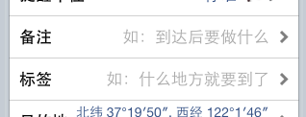

3. 2) Use the same Starting Time and Ending Time

3). You can save the battery power with "Time Notice". Your iPhone will receive notice requiring you to enable Place Clock at the Starting Time.

4) Due to the limit of iOS system, you need to click the Notice to enable the Place Clock.

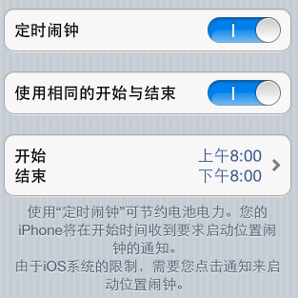

4、注：下面短句翻译的越简短越好

1) Distance to current location: Less than 0.1 km

2) Distance to current location: 0.1 km

3) Next Day (2nd Day)

4) Remind later

5) Remind 5 min later

6) Remind 30 min later

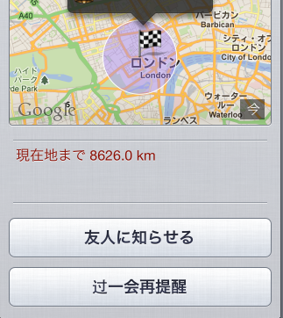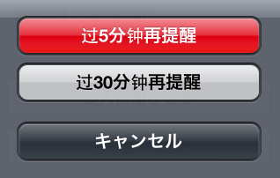

5. 1) As you are very near to this destination, it will remind you next time when you enter the area of the destination!

2) Reminder radius is too small, you may miss the reminder. Do not set a reminder radius like that, unless you can enssure your iPhone can receive GPS satellite signals without being kept out.

3) Click to enable "Place Clock"

4) Enabled!

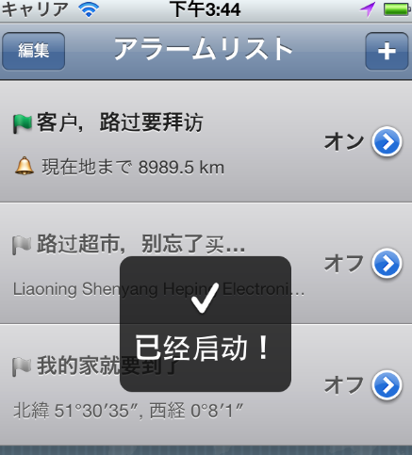

6. "Place Clock" is software reminding you the location. It runs in the background and reminds you when you are approaching to the destination.

★ If you are a salesperson, it can be used to mark the addresses of clients on the map. It will remind you when you pass by next time: there is/are client(s) nearby.

（注：中国习惯用“买酱油”代表买生活必须品，比较幽默，不知英语国家是否有类似的表达怎么说？买牛奶，啤酒？）

★If you are running out of life necessities, then you can mark the location of supermarket on the map first. It will remind you when you pass by the supermarket after work.

★ If you want to update your Microblog while you are on the bus to work, you can set the destination on the map first and the Place Clock will remind you to get off so that you will not miss your stop.

The “Place Clock” is a practical tool that allows you to immerse in thinking, games or dreams during your travel! As long as the destination has been set, the “Place Clock” will remind you in time when you are approaching to the destination.

Features:

★ You can designate time interval for enabling the “Location Based Service” through the "Time Notice" so as to save the battery power.

★ You can designate the determination to be reminded with map. The operation is very simple.

★ It is convenient to query address by interacting with iPhone address book.

★ It is fully background compatible without bothering you .

★ After a clock has been set, network connection is not required during its use.

The “Place Clock” is a good partner during your travel. You can immerse in your music, videos or games, or safely take a nap without missing your stop!